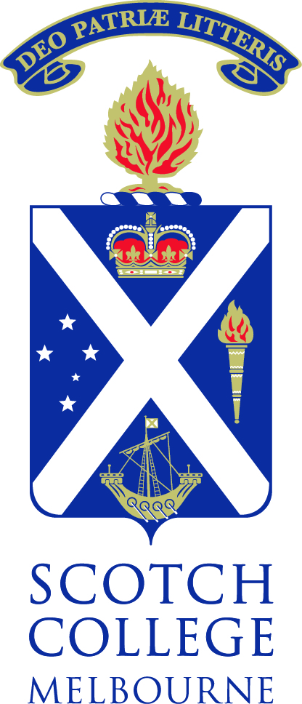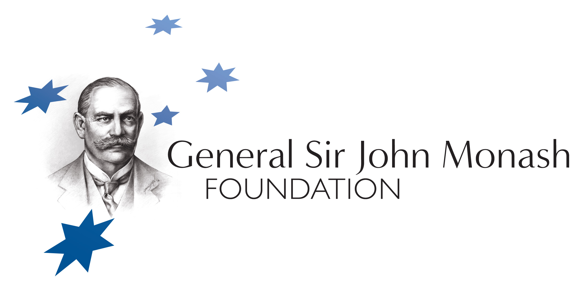

Joint Venture of 0808Inc., RCM– 0808, Spirit of Australia Foundation (SoA), Monash Foundation, Engineers Australia – Victoria (EA-V) and Scotch College
Monash Leadership Forum – Scotch College
9 Aug 2012 1.45-3.15pm

Cardinal Pavilion, Scotch College- Morrison St Hawthorn

Adopt as your fundamental creed that you will equip yourself for life,
not solely for your own benefit but for the benefit of the whole community
John Monash
Introduction and Welcome – Tom Goodwin – School Captain, Scotch College
Monash - Leader of Men – Prof Jeffrey Rosenfeld AM, Monash Medal 2012
His outstanding Leadership, Integrity and Service, contributes to the Australian community and beyond throughout his career as a leading international surgeon, researcher, clinician, military surgeon, humanitarian and advocate to reduce traumatic brain injury and landmine injuries.
Monash Scholarships – Educate Yourself for the Future
- Fergus Green - 2012 Monash Scholar

Discussion

Future of Engineering –
- Blair Stratton –Young Engineers –Victoria
Professional Engineer – Associate with Philip Chun
Significant Australians Project (SoA) – How to be involved
0808 Student participation and Prizes
- Dr. Kevin O'Flaherty – Convener 0808, Exec Dir. Spirit of Australia Foundation
Discussion

Conclusion
Refreshments and mingling

