2014 Gourmet FESTIVE Hamper

VALUE $225.00 plus…….YOURS FOR $150.00

The Christmas Hamper you have always wanted, consisting of all the delicacies that Christmas and you deserve
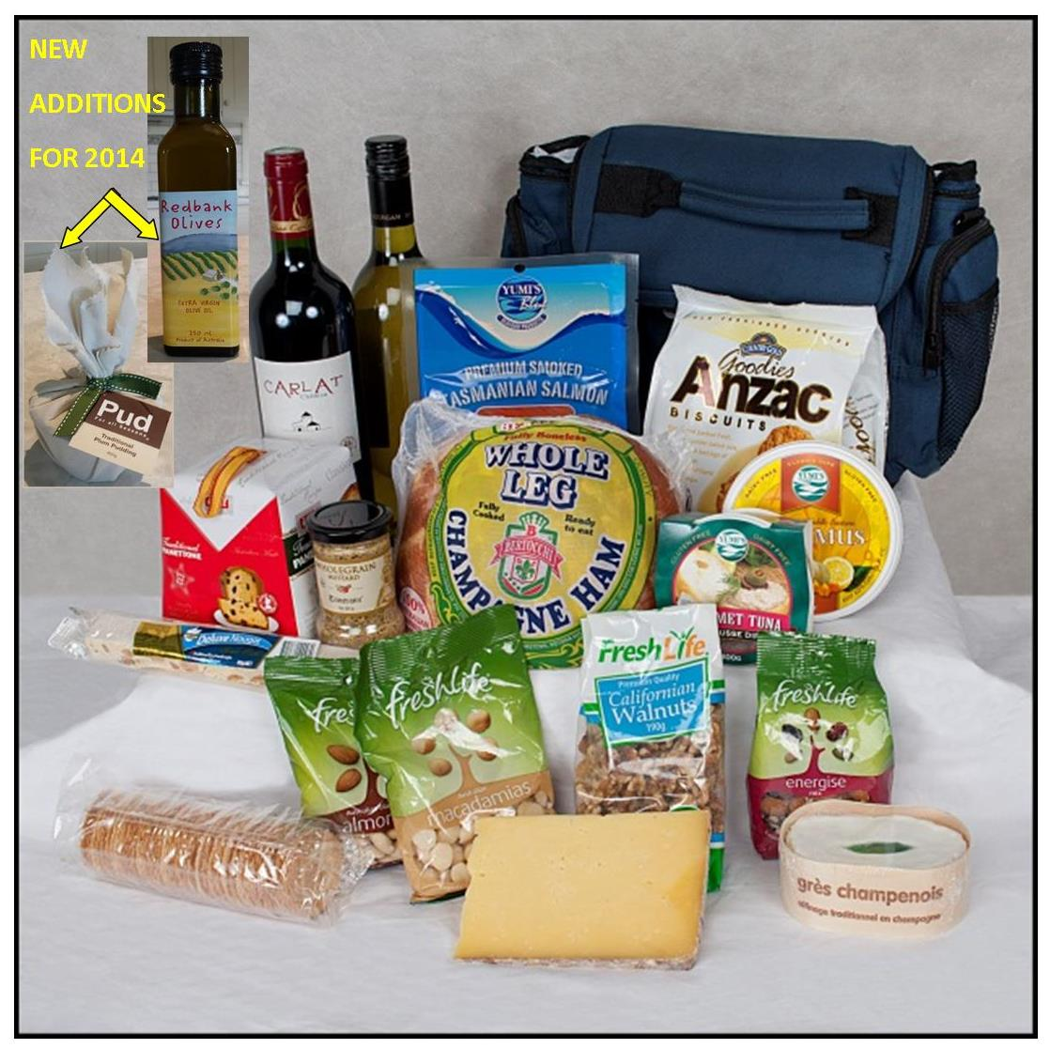
- 2kg Bertocchi Champagne Ham
- Yumi’s Smoked Salmon 100gm, Tuna Pate, Hommus Dip
- Tangy “Barbers Somerset UK” Cheddar
- French triple cream cheese
- Traditional Christmas Panettone (2)
- Anzac Biscuits, Crisp Biscuits, Fruit Slice, Europeans.
- Freshlife California Walnuts, Natural Almonds, Cranberries & Fruit Salad, Revitalise
- 100% Pure Honey (680gm) from the Victoria Central Goldfields Region
- 2012 Bulletin Cab Sauv & 2013 Chardonnay
- Redbank Olive Oil
- Meredith Fetta Cheese
- Pud Traditional Plum Pudding

Delivery Dates: Monday 22nd, Tuesday 23rd & Wednesday 24th December 2014

-------------------------------------------------------------------------------------------------------------------------------------------------------------------
2014 RCM GOURMET CHRISTMAS HAMPER ORDER FORM

Name…………………………………………………. Phone/Mob……………………………

Address (for delivery) ………………………………………………………...……………………..………….…….

Number of Hampers ………. @ $150.00 each = …………..
Payment Methods:
Credit Card: Cardholder Name ……………………………………. (Please circle one) Visa /Master/AMEX
Card No. _ _ _ _ _ _ _ _ _ _ _ _ _ _ _ _ Exp Date _ _ / _ _ Signature……………………………
EFT: Rotary Club of Melbourne Inc. BSB 013 030 Account 008 670 252, Notation ‘Your name hamper’
Cash: Cheque: Payable to Rotary Club of Melbourne Inc.

Remit orders & payment advice to PO BOX 18388 Collins St East Melbourne 8003 or office@rotaryclubofmelbourne.org.au

