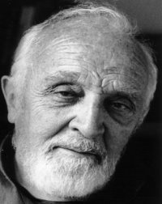**George Tippett - Rotary lnternational Service Above Self Awardee 1993-94**

This is the most heart-warming award. It means that the most senior of one’s colleagues have recognised your response to a challenge.

In our case primary dental care for the children in the Tibetan refugee camp in North India was followed by internationally significant research on Helicobacter and stomach ulcers in the monasteries of South India and worms in the children of Vietnam and the effect on their growth and cognitive development. Treatment was dramatically successful.

In Thailand we learnt as much as we taught in public dental health.

Finally we participated in the development of education programs in schools in Indonesia which demonstrated the effect on community compliance with public health advice and dramatic measurable improvement in vaccination rate and antenatal care.

The greatest satisfaction to me was to observe the progressive enlightenment of all the participants especially the Rotarians, not only here but also where we worked, as they came to understand the parameters of the problems we were addressing and the support they so willing gave.

PS I usually get a comment ‘that sounds good but what is happening now?’ - The program is still running in North India with a new leader and Rotarian Jamie Robertson, my original partner, is in Vietnam, teaching and group managing as I speak.