**ROTARY INTERNATIONAL SERVICE ABOVE SELF AWARD – PAST PRESIDENT, BOB GLINDEMANN**

As Rotary’s highest honour for individual Rotarians, this award recognizes up to 150 Rotarians annually who have demonstrated exemplary humanitarian service, with an emphasis on personal volunteer efforts and active involvement in helping others through Rotary.

At the recent D9800 District Conference, Past President Bob Glindemann was presented with this prestigious award by D9800 District Governor, Dennis Shore.

**General Biography**

Bob Glindemann was born in Brisbane in 1944. The eldest of five boys, he was educated at Cavendish Road High School.

He joined Shell Australia in 1959 and had postings across Australia and New Zealand during which time he gained extensive experience in logistics, supply chain and all aspects of marketing and sales in industrial, agricultural, mining and manufacturing markets.

Roles over that period culminated in global and regional leadership with his final appointment being Managing Director – Commercial, Oceania.

After retirement from Shell in 2001, Bob was the Principal of PRO: ED Vic Pty Ltd until retiring in 2006. He is married with two adult children.

In the 2011 Australia Day honours list Bob was awarded the Medal of the Order of Australia (OAM) for "service to the community through Rotary International and a range of social welfare, children's and motor sport organizations".

**Rotary Service Activities (including positions held in Rotary)**

Bob has been a Rotarian for 37 years.

President of Rotary Club of Darwin 1975/6 and Rotary Club of Melbourne 2003/4 (First club & largest membership in Australia).

Chairman of East Timor Committee of the Rotary Club of Melbourne to assist redevelopment as an independent nation 2004-2011.

Also a member of the following Rotary Club of Melbourne Committees: Centenary of Rotary, Horizons, Healthy Hearts.

Director of East Timor Roofing Holdings Pty Ltd 2009- Director of East Timor Roofing and Training UNIP LDA

Director of the Australian Embassy for Timor Leste Foundation Fund 2006-2009

Chairman Victorian Shell LiveWire Committee 1991-2004 (A joint initiative with Rotary to mentor young business entrepreneurs)

Chair D9800 RAWCS (Rotary Australia World Community Services Committee) - Primary international service program 1998-2012

D9800 "Donations in Kind" Leader. Hands on collecting and shipping to countries in need. 11,000+ volunteer hours annually.

**Non-Rotary Service Activities**

DIRECTOR CARE AUSTRALIA (overseas aid) 2008-. Member of Fundraising, Communications and Audit & Finance Committees. (CARE Australia is an Australian charity and international humanitarian aid organization fighting global poverty, with a special focus on empowering women and girls to bring lasting change to their communities).

DEPUTY CHAIRMAN Very Special Kids Foundation (provides counselling and support services to families caring for a child diagnosed with a life-threatening illness) 2002-

DIRECTOR SecondBite (Collects & distributes fresh food that would otherwise be wasted to people in need) 2006-, collections significantly through Rotary Clubs

DEPUTY CHAIRMAN and Non-Executive Director of Navy Health (health insurance and other services for Navy personnel) 2004-

**How This Recipient Embodies Service Above Self**

Bob Glindemann has devoted much of his life to help those less fortunate than himself. At the Rotary Club of Melbourne he regularly inspires and cajoles others to join him in new and existing projects. He is energetic, can do, committed and tenacious; leveraging these skills on his colleagues to produce amazing outcomes.

In 2003, Bob obtained A$500,000 from the Shell Foundation Sustainable Communities Grants for education and training in East Timor over three years.

In 2004 he obtained a $63,000 matching grant from The Rotary foundation to fund the Baucau Micro Credit Lending Bank in East Timor. He has made 4 extended visits to East Timor for hands-on project work.

His extensive business network enabled him to raise thousands of dollars worth of goods and equipment for the D1K Store (Donations In Kind) much of which goes to East Timor. At the Rotary Club of Melbourne Bob is the DIK Store champion and as a result most able bodied members have helped load shipping containers. Bob has literally spent weeks packing containers with useful goods and equipment for East Timor and other countries in dire need. Bob, in his innovative way was one of the instigators of the initiative to fund and build the Timor Leste Australian Embassy in Canberra. This was successfully completed in 2009.

He was an instigator and works tirelessly for the SecondBite initiative whereby food is collected by Rotarians at Melbourne markets for distribution to the homeless.

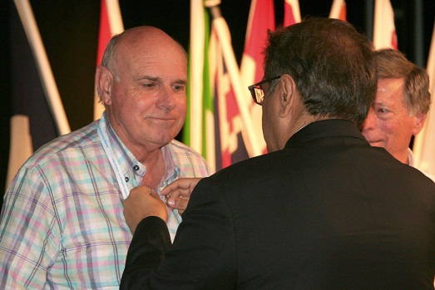We salute Bob G1indemann as an exemplar of Rotary's concept of SERVICE ABOVE SELF and a very appropriate recipient of the Rl Service Above Self Award.

Bob joins only two other Rotary Club of Melbourne recipients of this award – George Tippett (1993/1994) and Mev Connell (2009/2010).