Login | Register | Newsletters

Argus' grim warning to Australia
Robert Gottliebsen
Published 8:20 AM, 1 Mar 2012 Last update 8:20 AM, 1 Mar 2012

If you want to believe that all is well with the Australian economy do not read this commentary. Its inspiration comes from former NAB chief executive and BHP chairman Don Argus, who, fresh from setting out a blueprint which is already revitalising Australian cricket, has turned to the Australian economy.
He has produced a set of graphs that are truly scary and show we have a deep underlying problem. Next time you hear a government politician say that, deep down, Australia is in good shape, understand that it’s pure spin.
And just as Don Argus frightens us, so Paul Bloxham, chief economist at HSBC Australia, explains that Australia’s poor productivity means we must brace ourselves for lower growth, higher inflation and higher interest rates. Bloxham had not seen the Argus graphs but came to a similar conclusion with his own material.
So now fasten your safety belts and study the Argus graphs. The first graph is sourced from Bank of America Merrill Lynch’s Australian chief economist, Saul Eslake, and shows how dramatically Australia’s labour productivity has declined when compared to the US.
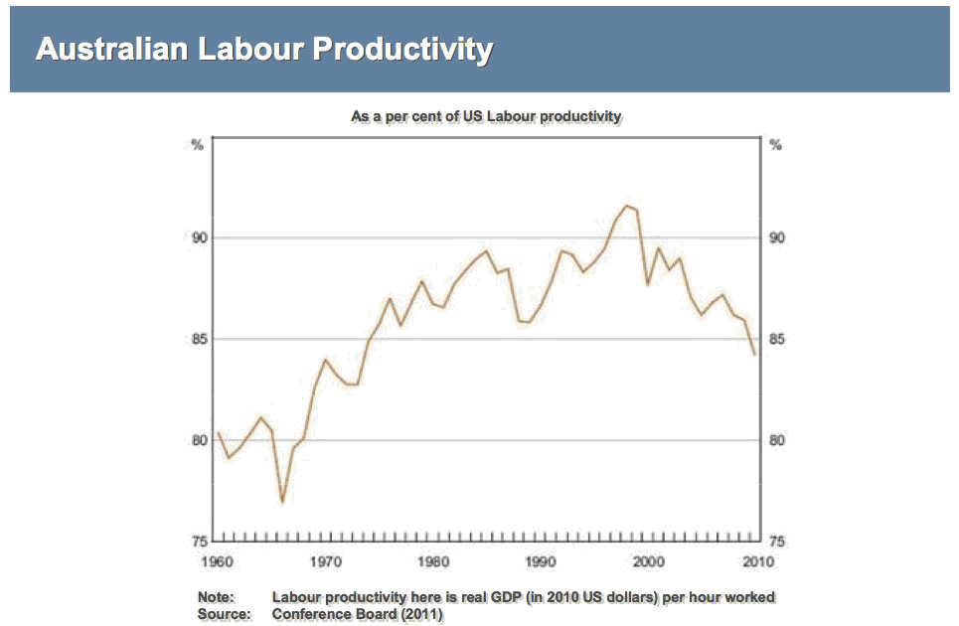
click the image to enlarge

Argus says that Australian workers’ productivity relative to their US counterparts is back where it was in the late 1970s. Put simply, over the past decade we have unwound the improvement in relative productivity that took 25 years to build between the late 1970s and the turn of the millennium. It's easy to blame workers but in fact it's more about managers who were driven by short-term profits and did not invest or who did silly deals with their workers which made investment uneconomic.
If you were scared by the first Argus graph then cop the second, which was prepared by Treasury boss Martin Parkinson to show where Australia generated its gross national income in the 1990s compared to the first decade of the twentieth century.
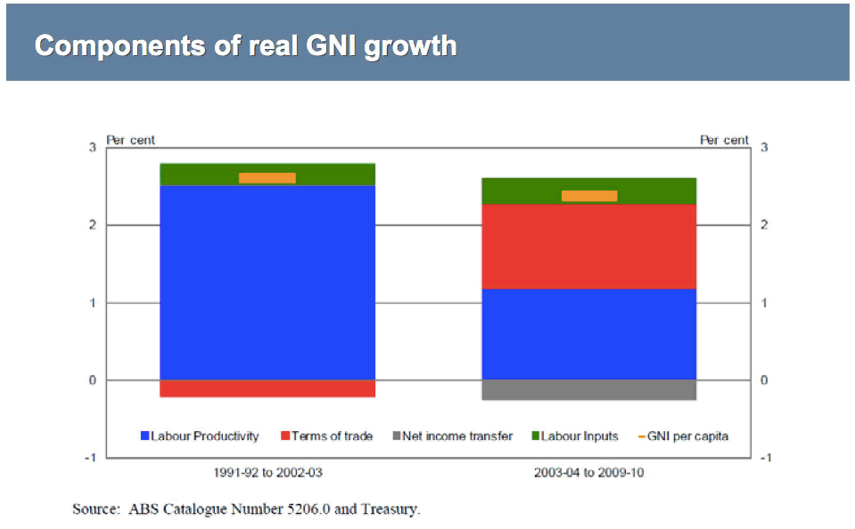
click the image to enlarge
The second Argus graph shows that Australian labour productivity growth – the blue bars – more than halved since the 1990s, but this was largely offset by the boost in the terms of trade – the red bars. We were lucky because, ordinarily, falling productivity would slash Australian living standards, but the deterioration in productivity growth has been masked by the unprecedented boost to the terms of trade that has occurred because of China’s rapid economic development.
My take on that second graph is that we need China more than any other country on earth.
But our plight is getting worse. The third Argus graph shows the number of working days lost in industrial disputes.
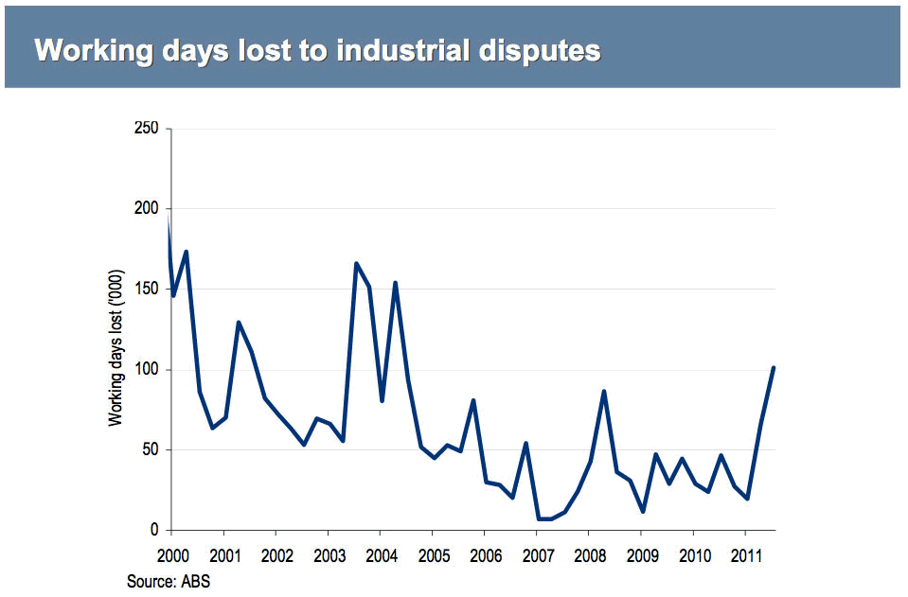
click the image to enlarge
Instead of improving productivity we are going headlong in the other direction, with many businesses facing strikes and the rising power of unions. Those strikes are often about reducing productivity as well as wage rises. The strikes go way beyond the high-profile cases of Qantas and Patrick and are now reaching very serious proportions because in the September quarter last year, we lost over 100,000 working days. That was the highest number of working days lost in one quarter for seven years.
And it gets worse because the biggest area of industry disputes is in the industry that has provided the wealth to cover our falling productivity – mining.
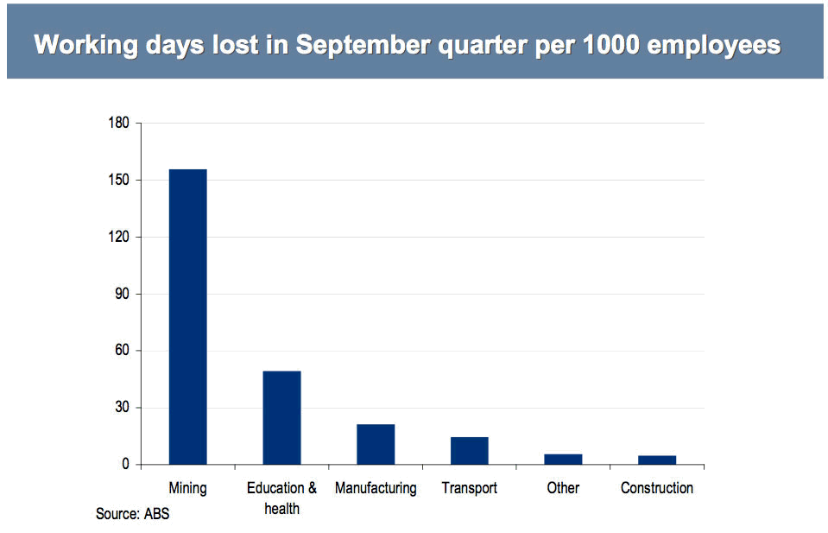
click the image to enlarge
Again, most of the mining strikes are not about pay but are about reducing the productivity of the mining industry.
As I have written, the strikes may succeed in causing BHP to mothball its Queensland coal expansion (Is BHP the new Qantas? February 27) but they will cause other miners to look elsewhere.
Because of the mess we have made of the rest of Australian employment we can’t afford that.
While it’s true that the Fair Work Act went too far and has propelled this attack on Australian living standards, the problem goes much deeper and relates to a malaise among Australian managers in both the private and public sectors.
And so we go back to Paul Broxham – get ready for lower Australian growth, higher inflation and higher interest rates which will decimate Australian high mortgage households.
Maybe we should encourage people to put the Argus graphs on the fridge so that people can see why they must pay more for their mortgages.
The Argus graphs and commentary were contained in Don Argus’ Angus Mitchell Oration, delivered to the Rotary Club of Melbourne yesterday.

