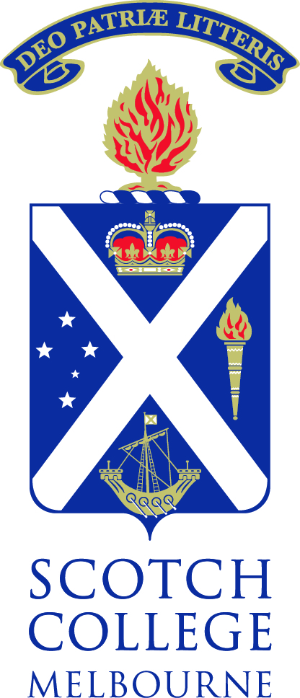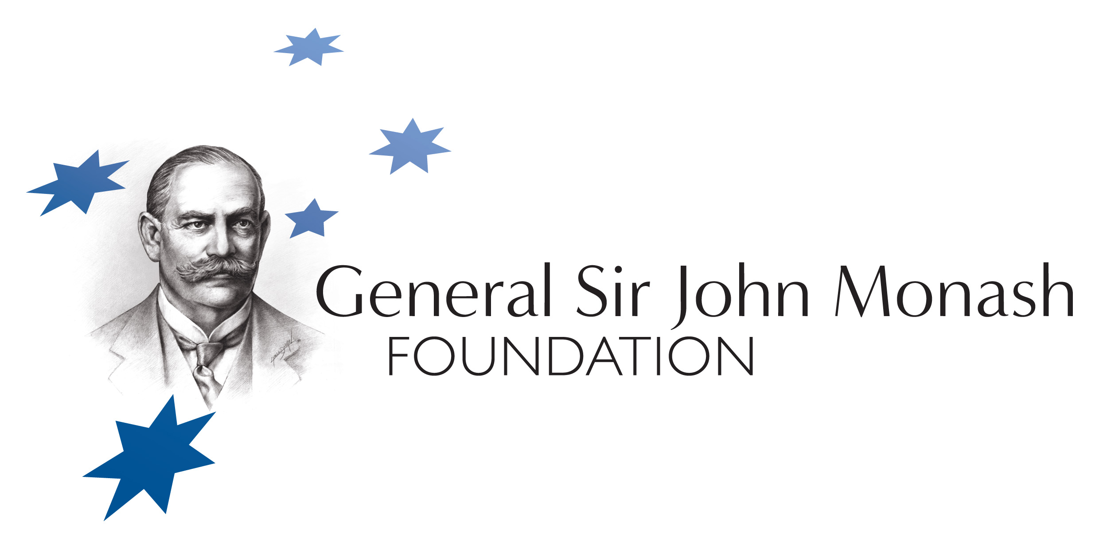

Tom Goodwin, School Captain, Scotch College 2012
Tom was Monash in the premiere of 1918-0808 at The Parliament of Victoria and The Shrine of Remembrance for 0808 and Spirit of Australia Foundation in 2011. The O’Flaherty-Kram composition was performed by Scotch College musicians and Senior Choir.

Jeffrey V. Rosenfeld AM, Monash Medal 2012
CStJMB BS(Melb), MD(Monash), MS(Melb), FRACS, FRCS(Edin), FACS,FRCS(Glasg) Hon, FCNST Hon, FRCST Hon, FACTM, MRACMA, RAAMC Professor and Head, Department of Surgery, Central Clinical School, Monash University,Professor and Director, Department of Neurosurgery, Alfred Hospital and Monash University; Director, Monash Institute for Brain Development and Repair
Jeffrey Rosenfeld is Professor and Head, Department of Surgery, Monash University and Director, Department of Neurosurgery the Alfred Hospital.

He is a Major General and the Surgeon General Defence Health Reserves, Australian Defence Force. He joined the Army Reserve in 1984 and has served on seven overseas operations including Rwanda, East Timor, Bougainville, Solomon Islands and Iraq. He is a world authority on military trauma particularly neurotrauma and an advocate to mitigate landmine use and injuries. In addition he has visited PNG, Fiji and the Solomon Islands multiple times for the AusAid funded Pacific Islands Project (PIP) to perform neurosurgery and teach.

Professor Rosenfeld has spearheaded the development of a Neuroscience Institute at Monash University to be named Monash University Institute for Brain Development and Repair (MUIBDR). Jeffrey is a Principal Investigator on the Monash University Bionic Eye Project which was awarded $8 million by the Australian Research Council.

In this 0808 week Jeffrey Rosenfeld was awarded the 2012 Monash Medal by The Rotary Club of Melbourne(RCM) for his outstanding Leadership, Integrity and Service, contributing to the Australian community and beyond throughout his career as a leading international surgeon, researcher, clinician, military surgeon, humanitarian and advocate to reduce traumatic brain injury and landmine injuries.

Fergus Green holds an Arts degree majoring in political science and a first-class honours degree in Law from the University of Melbourne, where he was the Editor of the Melbourne Journal of International Law and the recipient of numerous academic prizes. Fergus has also studied mandarin Chinese in Beijing and international relations at Georgetown University in Washington, DC. Currently a climate change and environmental lawyer at legal firm Allens Arthur Robinson and Chairman of the Centre for Sustainability Leadership, Fergus is also a widely published author on Australian and international climate change policy, including with the Lowy Institute for International Policy. For his contributions to climate law and policy, Fergus was named Australian Young Lawyer of the Year by Lawyers Weekly magazine in 2010.

Fergus will study for a Masters in Philosophy and Public Policy and then a PhD at the London School of Economics and Political Science (LSE). He plans to study the philosophical dimensions of public policy with a view to developing more effective climate change policies and governance frameworks.

Blair Stratton –Young Engineers –Victoria
Professional Engineer – Associate with Philip Chun
Blair holds degrees in chemical and process engineering as well as fire engineering from the University of Canterbury, Christchurch, New Zealand. His job is to design buildings so that people are protected from the effects of fire. He is passionate about the role of engineers in society.

Kevin O'Flaherty PhD, Convener 0808, Exec Director, The Spirit of Australia Foundation (SoA), Chair RCM-0808 Committee
Dr O'Flaherty convenes The Battle of Amiens Remembrance at The Shrine each 8 August (0808 – www.0808.org.au) to commemorate the Anniversary of the Australian Victory at The Battle of Amiens, 8 August 1918 by the Australian Army Corps, planned and led by General Sir John Monash.
0808 honors the detailed planning and meticulous execution of this significant battle and its victory by the Australian Forces united for the first time under Australian Command which led to the earlier than expected end to WW1.

Kevin developed the Significant Australians project of the SoA and the Monash Medal for RCM. The Medal is presented annually to an Outstanding Australian for Leadership, Integrity and Service, contributing to the Australian community and beyond. He is now seeking student and community help to tell the stories of Australian soldiers, nurses and other volunteers who were involved in 0808 in preparation for the centenary in 2018.
Dr O'Flaherty is writing a major poem 1918. Dr David Kram composed original music to these lyrics for 1918-0808 which premiered at Queen’s Hall, Parliament House, and at The Shrine for 0808 in 2011. Tom Goodwin was Monash as Scotch College musicians and senior choir performed the premieres.

